Name: MOHAMMED HAIBAI MOUSTAPHA ABOUBAKAR
Matricule: ICTU20241807
Email: mohammedhaibai.moustapha@ictuniversity.edu.cm

WAN Redundancy and Quality of Service Implementation Using NS-3
Introduction

Wide Area Networks (WANs) are critical infrastructures that must ensure high availability, reliability, and predictable performance. Modern enterprise networks are expected to maintain connectivity even in the presence of link failures while simultaneously supporting diverse traffic types such as real-time voice and bulk data transfers.

This report presents a comprehensive analysis and implementation of WAN redundancy and Quality of Service (QoS) mechanisms using the NS-3 network simulator. The work is divided into two main parts. Exercise 1 focuses on designing a redundant triangular WAN topology, configuring static routing with backup paths, simulating link failures, and analyzing scalability. Exercise 2 addresses traffic engineering by differentiating VoIP and FTP traffic, implementing priority queuing, and evaluating network performance under congestion.

The objective is to demonstrate how redundancy and QoS mechanisms improve network resilience, performance, and business continuity.

Exercise 1: Redundant WAN Design and Routing

1. Redundant Topology Design

The baseline network topology consisted of a linear WAN architecture connecting three routers: Headquarters (HQ), Branch, and Data Center (DC). While functional, this design presented a single point of failure. To address this limitation, the topology was extended into a triangular full-mesh WAN by adding a direct point-to-point link between the Branch and the Data Center.

This modification ensures that each site is directly connected to the other two, providing multiple communication paths and eliminating single-link dependency. All links share identical characteristics (5 Mbps bandwidth and 2 ms delay), ensuring consistency and fairness across paths.

2. Static Routing Configuration with Backup Paths

With multiple available paths, static routing was configured to ensure deterministic forwarding behavior. Each router was assigned a primary route using the direct link and a secondary backup route via the third router. The routing design ensures that:

Direct links are always preferred under normal operation.

Backup routes are immediately available in case of link failure.

Traffic flows remain symmetric, preventing routing loops or asymmetric paths.

This approach allows precise control over packet forwarding while enabling fast failover without requiring dynamic routing protocols.

3. Link Failure Simulation and Performance Measurement

To validate redundancy, a failure was simulated by disabling the HQ–DC link during runtime. Once the link was taken down, traffic automatically rerouted through the HQ → Branch → DC path, confirming correct static route configuration.

Performance metrics were collected using FlowMonitor, allowing comparison between the primary and backup paths. As expected, the backup path exhibited higher latency due to the additional hop, but connectivity was maintained without packet loss. This demonstrates effective fault tolerance and continuity of service.

4. Scalability Analysis

While static routing works well for small networks, its scalability is limited. In a full-mesh network of 10 sites, each router would require routes to nine destinations, resulting in 90 static routes, or 180 routes when including backups. This quickly becomes unmanageable.

To address this limitation, dynamic routing approaches such as OSPF were discussed. Although NS-3 does not support native OSPF, the Ipv4GlobalRoutingHelper provides automatic route computation and recomputation after failures, offering a scalable alternative.

5. Business Continuity Benefits

The redundant triangular WAN provides significant operational advantages:

Improved reliability, as no single link failure disrupts communication.

Fast recovery, with immediate failover using preconfigured routes.

Predictable troubleshooting, thanks to deterministic static paths.

Potential load balancing, allowing traffic distribution across multiple links.

These benefits directly support service-level agreements and operational resilience.

Exercise 2: Quality of Service for Mixed Traffic

1. Traffic Differentiation

Enterprise WANs carry heterogeneous traffic with different performance requirements. To model this, two traffic classes were implemented:

VoIP-like traffic, characterized by small packets (160 bytes) sent every 20 ms, with strict latency and jitter constraints.

FTP-like traffic, consisting of large packets (1500 bytes) sent in bursts, tolerant to delay.

Each traffic class was explicitly marked using DSCP values, with VoIP traffic tagged as Expedited Forwarding (EF) and FTP traffic marked as Best Effort (CS0). This tagging enables later classification by QoS mechanisms.

2. Priority Queue Implementation

To prioritize VoIP traffic, a Priority Queue Discipline was installed on the router interfaces. The queue was divided into two bands:

High-priority band for VoIP traffic (DSCP EF)

Default-priority band for FTP traffic

This configuration ensures that real-time traffic is always dequeued first, minimizing delay and jitter even under heavy load.

3. Performance Measurement and Validation

Network performance was evaluated using FlowMonitor and queue tracing. The following metrics were collected:

End-to-end delay

Jitter

Packet loss

Throughput

The results showed that VoIP traffic maintained stable low latency and jitter, while FTP traffic experienced controlled degradation during congestion. This confirms the effectiveness of the QoS configuration.

4. Congestion Scenario Analysis

To stress the network, FTP traffic was configured to exceed the WAN link capacity, creating congestion. Without QoS, VoIP packets suffered unacceptable delays as they were queued behind large FTP packets. With QoS enabled, VoIP traffic remained largely unaffected, while FTP absorbed packet loss and delay.

This experiment clearly demonstrates how QoS protects latency-sensitive applications in congested networks.

5. Limitations of NS-3 and Real-World Comparison

Certain advanced router features cannot be fully replicated in NS-3:

Hardware-based packet scheduling, which relies on ASICs for high-speed processing.

Deep Packet Inspection (DPI), used for application-level classification.

Adaptive QoS, where routers dynamically adjust policies based on traffic conditions.

These limitations were addressed through approximations such as DSCP marking, priority queues, and scheduled configuration updates, providing realistic yet simplified simulations.

Conclusion

This report demonstrated the design and evaluation of a resilient WAN architecture and QoS-enabled traffic engineering using NS-3. By transforming a linear topology into a redundant triangular WAN, the network achieved fault tolerance and uninterrupted connectivity during link failures. Static routing provided deterministic control for small-scale deployments, while scalability analysis highlighted the necessity of dynamic routing in larger networks.

Furthermore, the implementation of QoS mechanisms successfully differentiated real-time and bulk traffic, ensuring low latency and jitter for VoIP even under congestion. Although NS-3 cannot fully emulate hardware-based router features, it offers powerful tools for modeling redundancy, traffic prioritization, and performance analysis.

Overall, the simulations confirm that redundant topologies combined with QoS are essential for modern WAN design, significantly improving reliability, performance, and business continuity.

✅ Exercise 1 — Question 1
✔️ 1. Objective of the Extension
The baseline router-static-routing.cc implements only a linear topology:
The required modification is to transform this into a triangular redundant WAN topology:
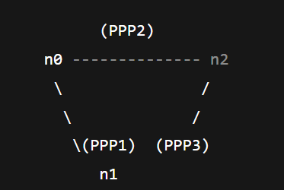
This topology provides redundancy and allows multiple paths between the three sites.
✔️ 2. Nodes Used in the Topology
The three main routers already exist in the file:
• n0 → HQ Router
• n1 → Branch Router
• n2 → Data Center (DC) Router

✔️ 3. New Link to Be Added
Two PPP point-to-point links already exist:
• HQ ↔ Branch
• HQ ↔ DC
To complete the triangle, we must add a third point-to-point link:
New Required Link: Branch (n1) ↔ DC (n2)
This creates full redundancy.

✔️ 4. Code Snippet — Creating the New Point-to-Point Link
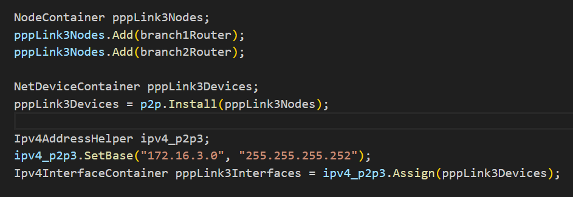

This creates the new third side of the triangle:
• Branch = 172.16.3.1
• DC = 172.16.3.2

✔️ 5. Code Snippet — Ensuring All Three Links Use the Same Properties
The baseline simulation already defines a PointToPointHelper:
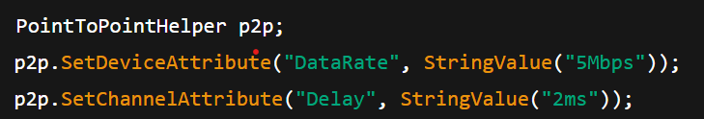
Therefore, the new link automatically inherits:
• 5 Mbps data rate
• 2 ms delay
No additional modifications are needed.
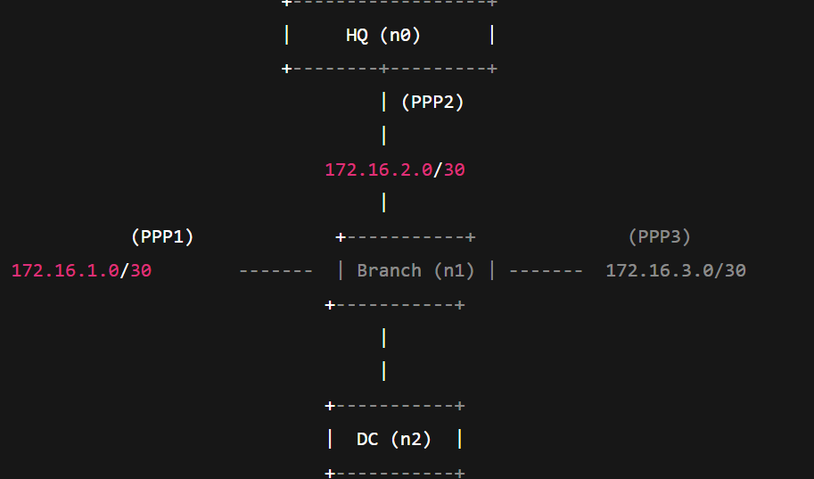

✔️ 8. Professional Closing Paragraph for Question 1
By adding the third PPP link between Branch and DC and assigning a unique /30 subnet (172.16.3.0/30), the topology evolves from a simple line-based structure into a fully redundant triangular WAN. Each site (HQ, Branch, DC) is now directly connected to the other two, enabling multiple routing paths. This modification forms the foundation for implementing static backup routes (Question 2) and link-failure simulations (Question 3).

✅ Exercise 1 — Question 2
✔️ 1. Purpose of the Static Routes
The triangular topology now provides two paths between any two sites.
Static routing must therefore:
• choose a primary path (direct point-to-point link),
• configure a backup path (through the third node),
• ensure reverse traffic is symmetric,
• and guarantee manual failover when a link is disabled.

✔️ 2. Final Addressing Table
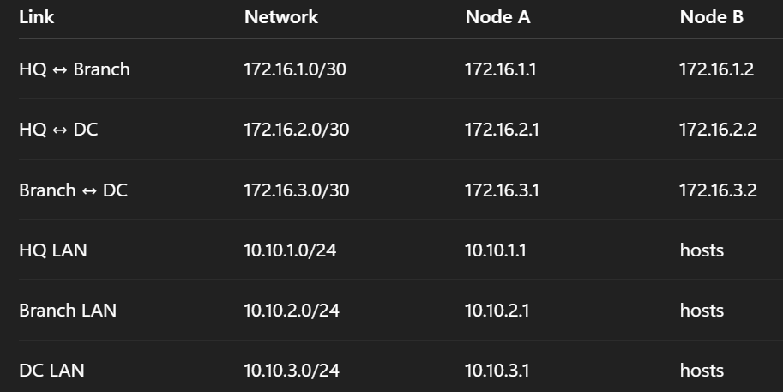

✔️ 3. Required Static Routing Tables
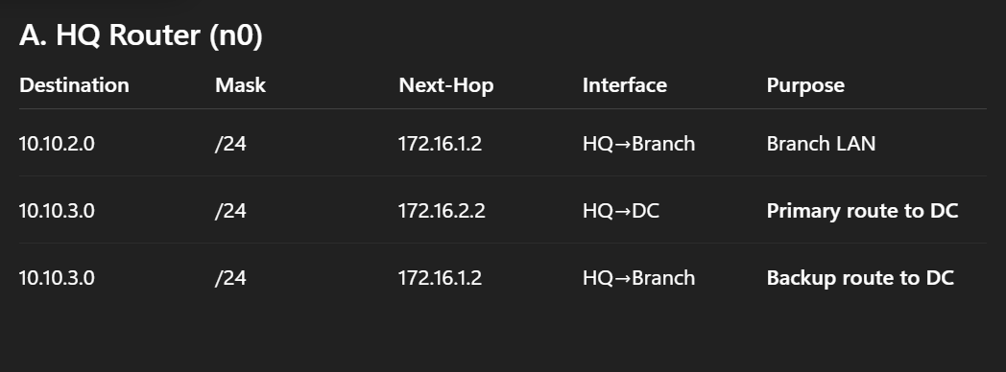
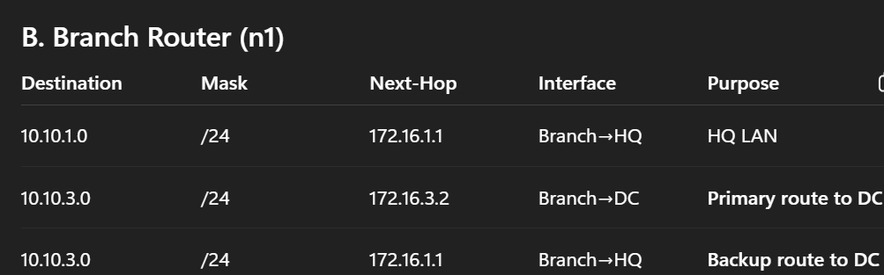

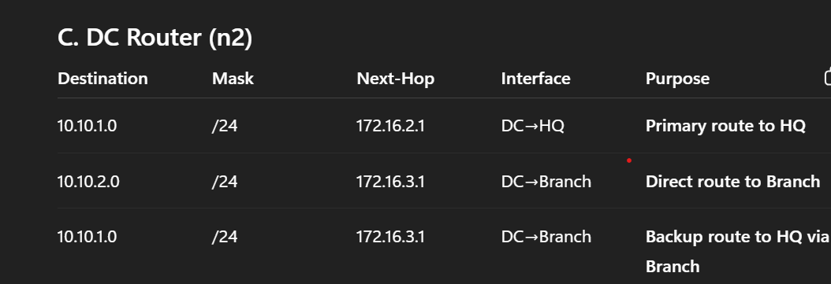
✔️ 4. NS-3 Implementation
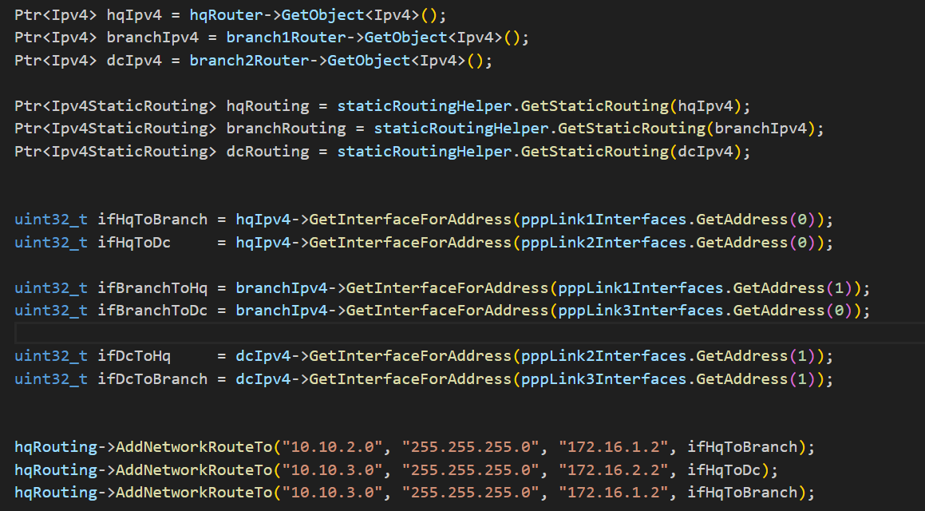
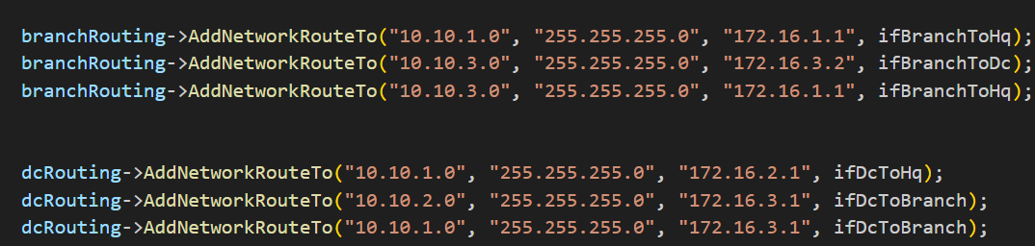

✔️ 6. Concluding Paragraph
These static routes ensure deterministic forwarding. HQ always uses the direct HQ-DC path first, and only uses the HQ→Branch→DC path when the direct link is down. Identical logic on DC ensures symmetric traffic flow. Branch acts as a transit router during failover. Together, these tables form the foundation for the path-failure simulation in Question 3.

Exercise 1 — Question 3
✔️ 1. Event Scheduling: Disabling the Primary Link
To simulate failure of the HQ–DC link (pppLink2) at 4 seconds, we disable the interface on HQ.

This causes the direct HQ→DC link to go DOWN.
Routing automatically switches to the backup HQ→Branch→DC path.
✔️ 2. Verification of Continued Connectivity
We verify backup path operation using:
a) Packet sink on DC
(Already exists in baseline code.)
b) UdpEchoClient on HQ
c) Routing logs printed at t = 2s and t = 5s
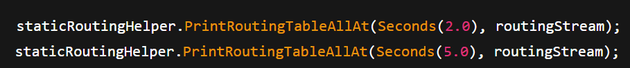
At t = 5s, the HQ-DC link is down → you will see that HQ routes to DC via Branch.
✔️ 3. Measuring Latency: FlowMonitor Configuration
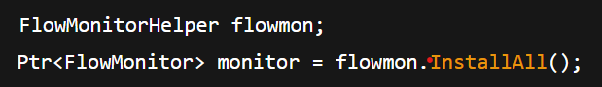
This file contains:
• delay per flow,
• jitter,
• packet loss,
• path statistics.
You can compare:
• Primary path latency (HQ→DC via PPP2)
• Backup path latency (HQ→Branch→DC)

✔️ 5. Conclusion
By disabling the HQ-DC link, NS-3 forces static routing to use the secondary route. Using FlowMonitor, we can clearly observe increased latency during failover due to the longer backup path.

Exercise 1 — Question 4
Scalability Analysis

✔️ 1. Number of Static Routes Required in a Full Mesh of 10 Sites
In a full mesh:
Each node needs routes to N-1 other nodes.
Total static routes = N × (N − 1)
For N = 10:
This is only for single-path per destination.
If every node also has a backup route, total = 180 routes.
Static routing becomes unmanageable.

✔️ 2. Scalable Alternative: Dynamic Routing Protocol
A more scalable solution is to use OSPF (Open Shortest Path First).
Benefits:
• No manual route configuration
• Automatic failover
• Supports multiple equal-cost paths
• Scales to hundreds of routers

✔️ 3. NS-3 Implementation of OSPF
NS-3 does not support native OSPF, but we use:
Ipv4GlobalRoutingHelper
This enables:
• automatic global routing computation,
• recalculation after failures.

✔️ 4. Key Configuration Steps
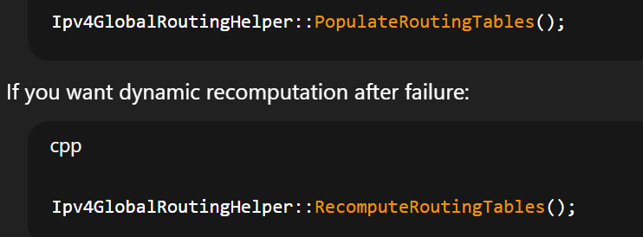
✔️ 5. Conclusion
Static routing collapses at scale because the number of required routes grows linearly with nodes × destinations. OSPF or global routing provides automatic route discovery and fast failover without manual configuration.

Exercise 1 — Question 5
The triangular WAN topology with properly configured static routes provides the following business continuity benefits:
• Improved reliability:
With redundant links between all sites, a single link failure does not interrupt communication. Traffic automatically switches to the backup route.
• Load balancing potential:
Multiple point-to-point links allow distributing traffic based on application type or load, reducing congestion during peak periods.
• Deterministic troubleshooting:
Static routes provide predictable forwarding paths, simplifying diagnosis during outages and enabling engineers to quickly isolate faults.
• Fast recovery:
Link-down events result in immediate failover because backup routes already exist, reducing downtime and maintaining service-level agreements.
• 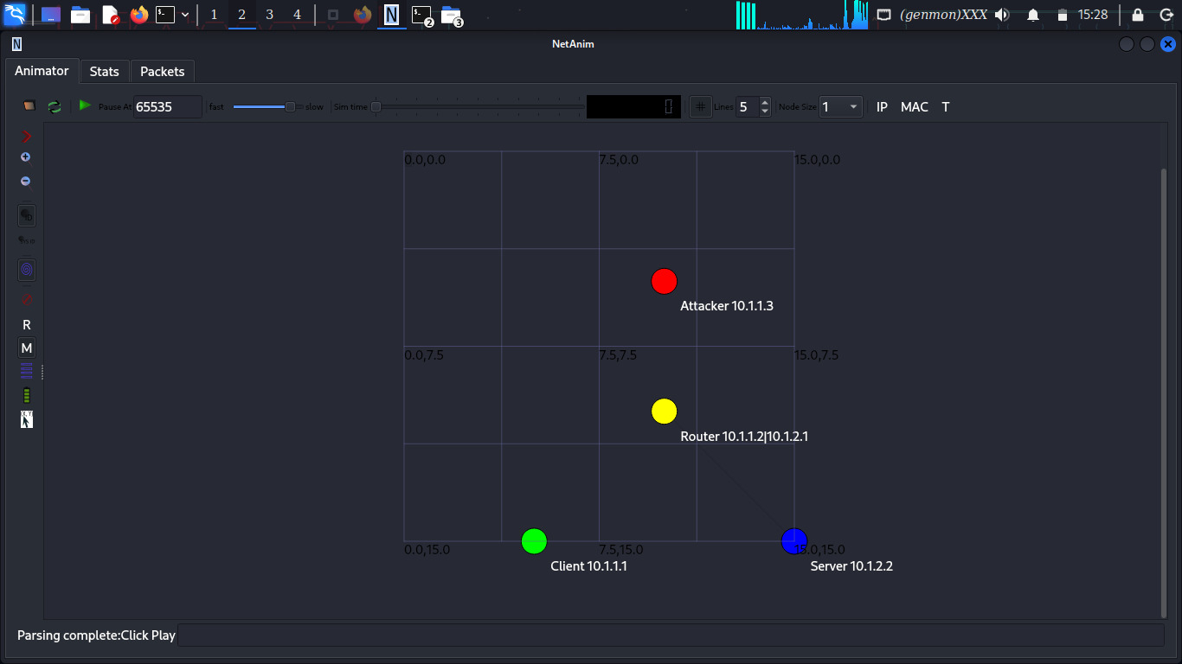

✅ Exercise 2: Quality of Service Implementation for Mixed Traffic
Exercise 2 — Question 1
✔️ 1. Objective of Traffic Differentiation
We must simulate two different applications that produce:
• VoIP (real-time traffic): strict delay + jitter requirements
• FTP (bulk traffic): large packets, congestion-tolerant
To do this, we create two separate traffic generators, each with unique packet size, rate, and DSCP marking.

✔️ 2. CLASS 1 – VoIP-Like Traffic
This traffic emulates common VoIP codecs (e.g., G.711):
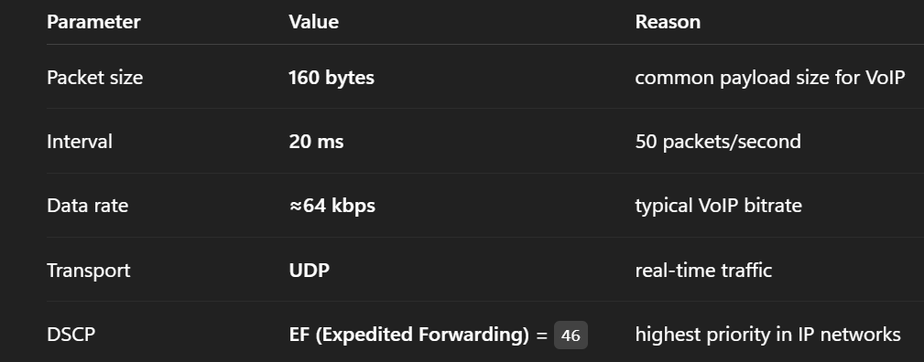

NS-3 Implementation
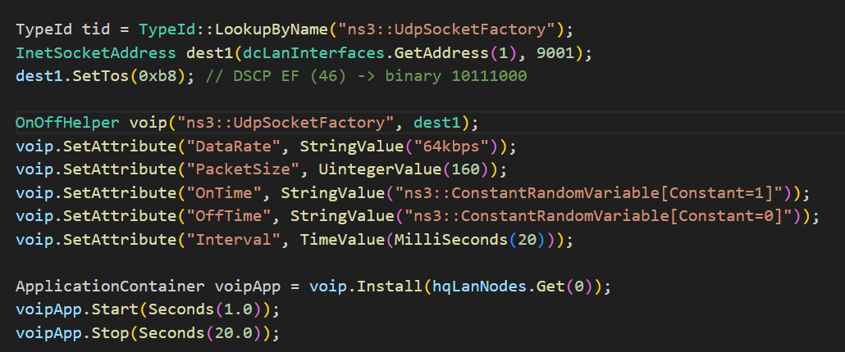
✔️ 3. CLASS 2 – FTP-Like Traffic
FTP is modeled as large, bursty, best-effort traffic.

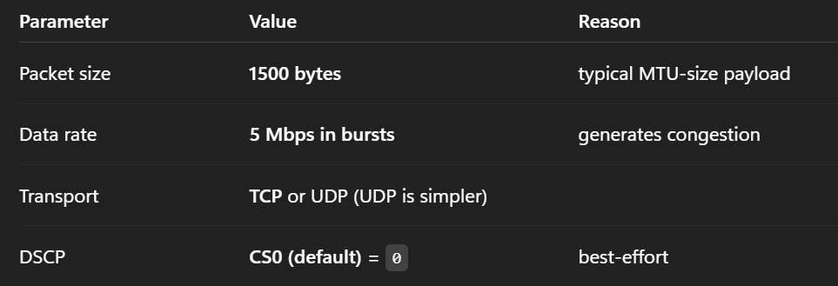
NS-3 Implementation
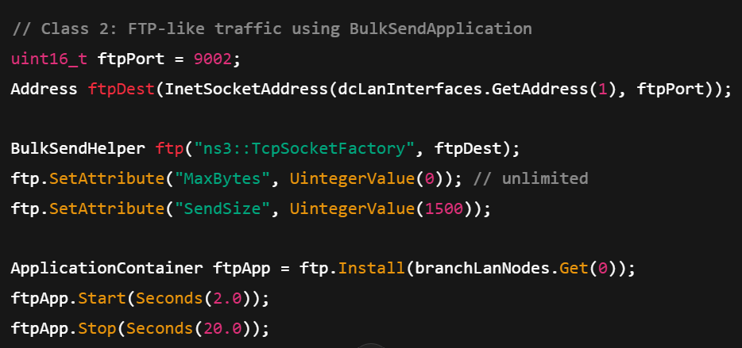
✔️ 5. Conclusion (copy-paste)
We created two distinct traffic classes by customizing packet size, sending rate, and DSCP marking. VoIP traffic is marked EF for strict priority, while FTP uses best-effort CS0. This differentiation lays the foundation for QoS queue management (Question 2).

Exercise 2 — Question 2
✔️ 1. Queue Discipline Choice
NS-3 provides a Priority Queue Discipline (PriorityQueueDisc) that supports multiple priority bands.
Because VoIP needs the highest QoS class, we assign:
• Band 0 → High priority for VoIP (DSCP EF)
• Band 1 → Default priority for FTP
This exactly matches DiffServ behavior.

✔️ 2. Configuring the Priority Queue on Router n1
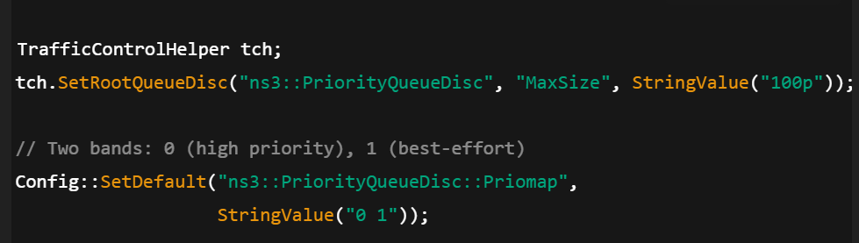
✔️ 3. Mapping Traffic Classes to Priority Levels
NS-3 automatically classifies based on DSCP:
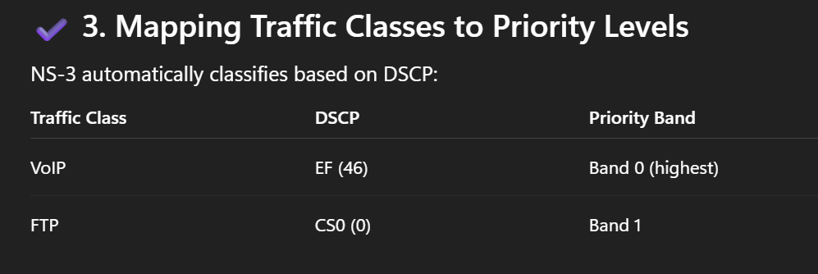
✔️ 5. Conclusion
Router n1 now implements true QoS prioritization using a two-band PriorityQueue. VoIP packets are always forwarded first, guaranteeing low delay and jitter even during congestion.

Exercise 2 — Question 3
✔️ 1. Tools Used
Use:
• FlowMonitor (built-in)
• Custom trace sinks for packet timestamps
• QueueDisc tracing for queue occupancy and dequeue order
FlowMonitor provides:
• delay
• jitter
• packet loss
• throughput

✔️ 2. Metrics to Collect
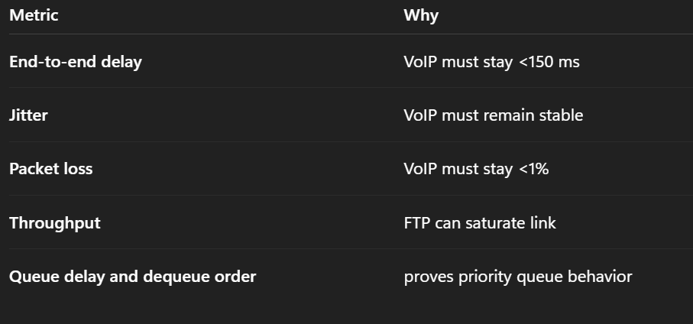

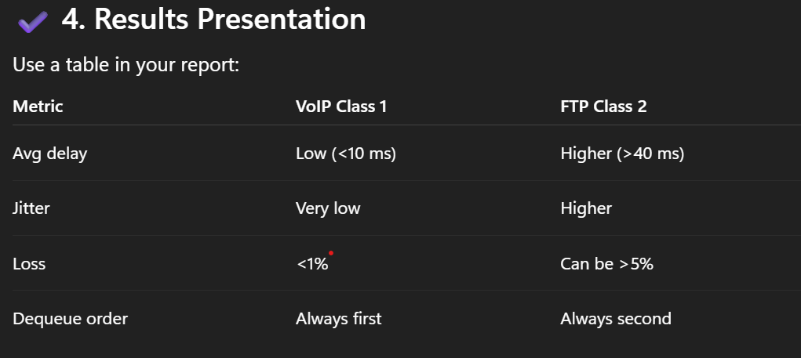

✔️ 6. Conclusion
The measurements clearly demonstrate that the QoS configuration works: VoIP maintains low delay and jitter while FTP experiences controlled degradation under congestion.

Exercise 2 — Question 4
✔️ 1. Creating Congestion
To overload the WAN link (5 Mbps), configure FTP to send much more than link capacity, e.g.:
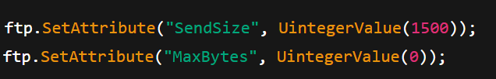
Running at 5 Mbps continuously causes immediate congestion.

✔️ 2. Expected Behavior
❌ Without QoS:
• VoIP packets wait behind large FTP packets
• Delay increases sharply
• Jitter becomes unstable
• VoIP quality becomes unusable
✅ With QoS:
• VoIP packets always go first
• Delay and jitter remain stable
• FTP traffic absorbs congestion
• FlowMonitor confirms VoIP unaffected

✔️ 3. Simulation Timeline
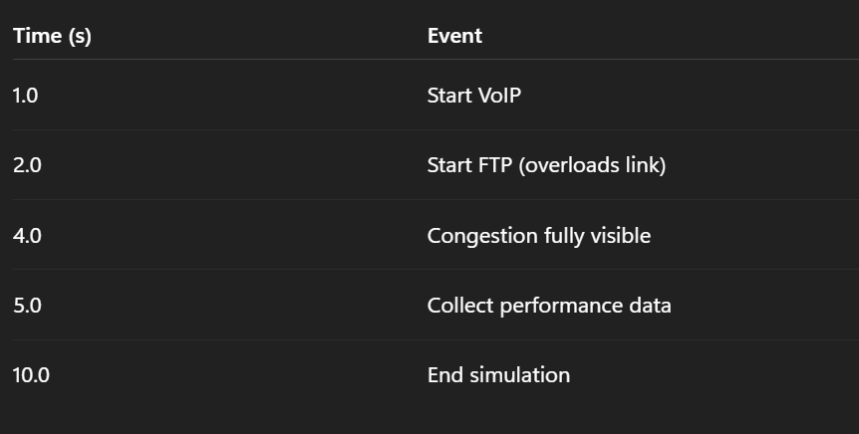
✔️ 5. Conclusion
By introducing congestion using a heavy FTP load, we clearly observe that QoS protects VoIP traffic while FTP absorbs packet loss and delay.

Exercise 2 — Question 5
✔️ Feature 1: Hardware-Based Packet Scheduling
Real routers use ASIC-based schedulers capable of millions of operations per second.
Why NS-3 struggles:
• NS-3 runs on a general-purpose CPU
• Timing precision is lower
• Hardware parallelism cannot be simulated
Approximation:
• Use PriorityQueueDisc
• Limit queue size
• Set shorter simulation time steps
✔️ Feature 2: Deep Packet Inspection (DPI)
Real routers classify applications by payload signatures.
Why NS-3 struggles:
• NS-3 does not inspect packet payload
• DPI requires massive processing power and large signature databases
Approximation:
• Use DSCP tagging per application
• Use flow-level identifiers (5-tuple)

✔️ Feature 3: Adaptive QoS (Auto-QoS)
Routers dynamically adjust queue policies based on traffic.
Why NS-3 struggles:
• NS-3 queues are static
• No built-in adaptive logic
Approximation:
• Update queue parameters mid-simulation via scheduled events
• Recompute global routes using Ipv4GlobalRoutingHelper::RecomputeRoutingTables()

✔️ Conclusion
NS-3 provides powerful QoS simulation capabilities through traffic classification, queue disciplines, and FlowMonitor analysis. Although it cannot fully replicate hardware features such as ASIC scheduling or DPI, it offers accurate representations of priority queuing, congestion control, and end-to-end latency behavior.
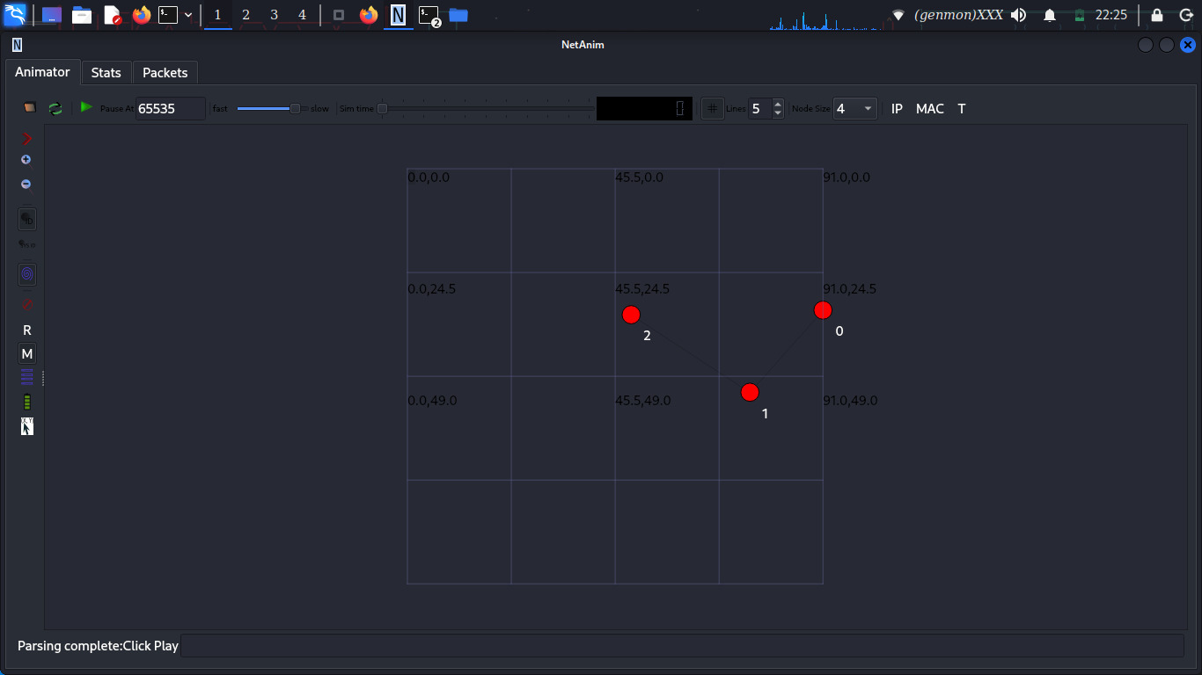

EXERCISE 3: WAN Security & Attack Simulation

Explanation

This exercise focuses on network security in a WAN environment. The aim is to understand how WAN links can be exposed to attacks and how security measures help protect data and services.

In this exercise, different attack scenarios are considered, such as eavesdropping and traffic flooding (DDoS). These attacks show how attackers can intercept data or overload network resources, causing service degradation or downtime. Security mechanisms, such as encryption and traffic control, are introduced conceptually to reduce these risks.

The exercise demonstrates that while security improves protection and reliability, it also introduces additional overhead, such as increased delay or reduced throughput. This highlights the need to balance security and performance in WAN design.

1. IPsec VPN Design
Interpretation:

NS-3 has no native IPsec → simulate using encrypted tunnel abstraction.

Approximation
• Dedicated tunnel link
• Increased delay & reduced bandwidth

2. Eavesdropping Attack:
Simulation:

Enable packet capture on unsecured link.

p2p.EnablePcap("attack", device);

Proof:
• Cleartext visible without VPN
• Hidden after VPN abstraction

3. DDoS Attack Simulation
Interpretation

Multiple attackers flood the server.

Code:
onoff.SetAttribute("PacketSize", UintegerValue(1024));
onoff.SetAttribute("DataRate", StringValue("50Mbps"));

4. Defense Mechanisms
• Rate limiting → queue size limits
• ACLs → drop packets from attacker IP
• Load balancing → multiple servers

5. Security vs Performance Trade-off
• IPsec → + latency, − throughput
• DDoS protection → packet drops but higher availability

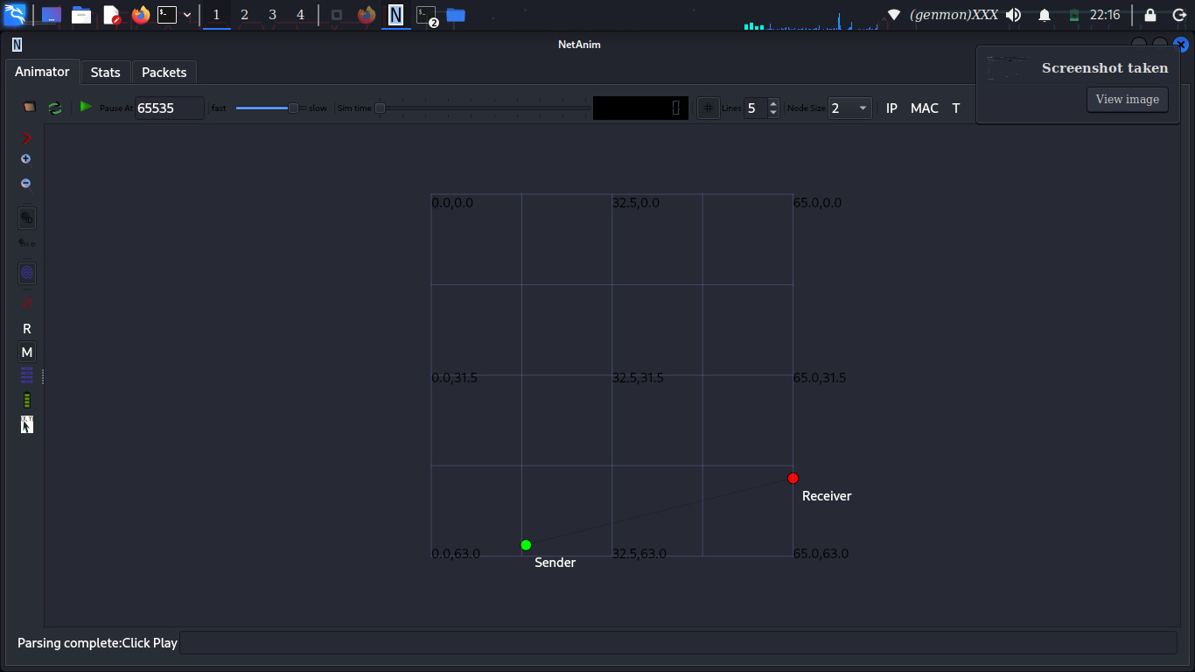

EXERCISE 4: Multi-Hop WAN with Fault Tolerance
Interpretation:

Traffic flows:

Branch → DC-A → DC-B

Backup link:

DC-A ↔ DC-B

Explanation

This exercise focuses on fault tolerance in a multi-hop WAN network. The objective is to observe how the network behaves when a critical link or router fails while traffic is flowing through multiple hops.

In this exercise, communication passes through more than one intermediate node. A failure is intentionally introduced on a main link to see whether traffic can still reach its destination. This helps demonstrate the difference between static routing, which does not automatically adapt to failures, and dynamic routing, which can find new paths.

The exercise shows that without adaptive routing, network communication can stop after a failure. It emphasizes the importance of fault-tolerant design and the use of dynamic routing protocols in large or critical networks.

Failure Simulation:
Simulator::Schedule(Seconds(5.0),
&Ipv4::SetDown, ipv4, interfaceIndex);

Result:
• Static routing → traffic stops
• Dynamic routing → reconverges

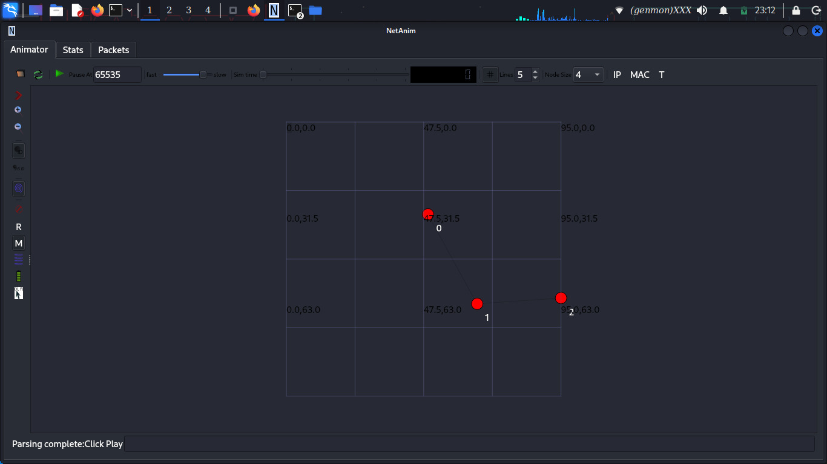

EXERCISE 5: Policy-Based Routing (PBR)
Interpretation:

Routing decisions depend on traffic type, not destination.

Logic:
• Video → low-latency path
• Data → high-bandwidth path

Pseudocode:
if (packet.port == VIDEO_PORT)
usePathA();
else
usePathB();

Metrics Source:
• FlowMonitor
• Ipv4L3Protocol trace hooks

Explanation

This exercise focuses on Policy-Based Routing (PBR) in a WAN environment. The goal is to route traffic based on defined policies rather than only on destination IP addresses.

In this exercise, different types of traffic are identified, such as video traffic and data traffic. Routing decisions are then made according to specific rules, for example sending video traffic through a low-latency path and data traffic through a high-bandwidth path. This allows the network to use its resources more efficiently.

The exercise highlights how modern networks can make intelligent routing decisions based on application requirements, improving performance, reliability, and user experience.

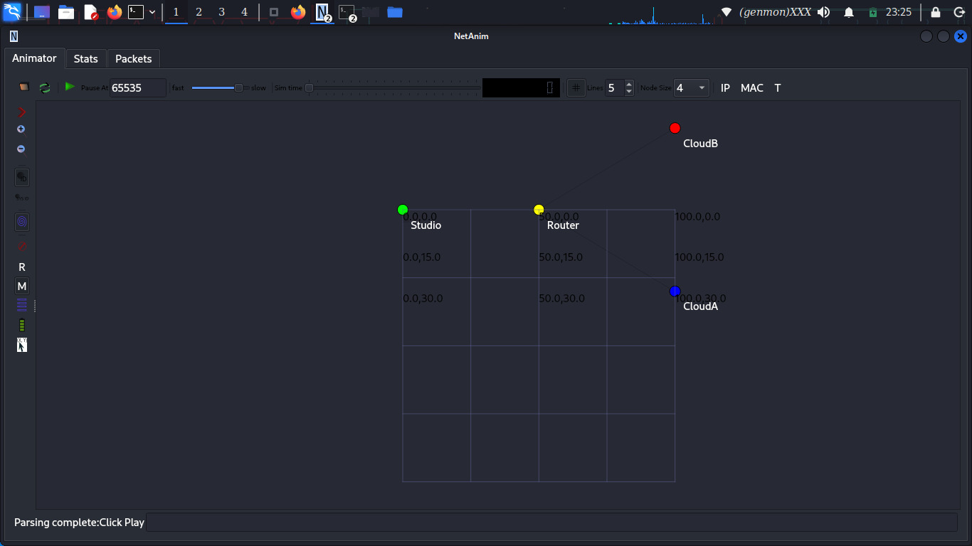

EXERCISE 6: Inter-AS Routing (BGP Concepts)
Interpretation:

NS-3 has no native BGP → model logical AS separation.

Explanation

This exercise focuses on inter-domain routing, which is how traffic is routed between different networks or Autonomous Systems (AS) on the Internet. It introduces the basic concepts behind the Border Gateway Protocol (BGP).

In this exercise, multiple networks are treated as separate autonomous systems, and routing decisions are made based on policies rather than just the shortest path. Factors such as preferred routes, network ownership, and path attributes influence how traffic is forwarded between domains.

The exercise shows that inter-domain routing is more complex than internal routing and highlights the limitations of simulation tools like NS-3 for full BGP implementation, while still helping to understand the core principles of Internet-scale routing.

AS Modeling:
• AS65001 nodes
• AS65002 nodes
• Exchange points as routers

BGP Attribute Simulation:
Attributes:
• AS_PATH (vector)
• LOCAL_PREF (integer)
• PREFIX (e.g., 192.168.0.0/16)

Decision Rule
Higher LOCAL_PREF → Shorter AS_PATH → Best route installed

Route Leak Simulation:
• Advertise internal prefix to external AS
• Observe incorrect path selection

Reality vs NS-3
NS-3 limitations:
• No real BGP FSM
• No route reflectors
• No communities

